**SOAP Programming With Annotations:**

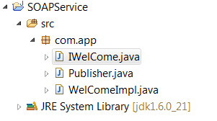

**package** com.app;

**import** javax.jws.WebMethod;

**import** javax.jws.WebService;

**import** javax.jws.soap.SOAPBinding;

**import** javax.jws.soap.SOAPBinding.Style;

@WebService

@SOAPBinding(style=Style.*DOCUMENT*)

**public** **interface** IWelCome {

@WebMethod(operationName="sample")

**public** String showWelComeDetails(String pname,**int** num);

}

**package** com.app;

**import** javax.jws.WebService;

@WebService(endpointInterface="com.app.IWelCome",name="examplename1",portName="exampleport1",serviceName="sampleservice1")

**public** **class** WelComeImpl **implements** IWelCome {

@Override

**public** String showWelComeDetails(String pname,**int** num) {

**return** "done"+10;

}

}

**package** com.app;

**import** javax.xml.ws.Endpoint;

**public** **class** Publisher {

/**

* **@param** args

*/

**public** **static** **void** main(String[] args) {

Endpoint.*publish*("http://localhost:9000/WS/hello", **new** WelComeImpl());

}

}

To create a client project :

Create a sample project -> Copy the location of src -> open cmd prompr of that location and type

As below

wsipmort -keep “location of srce folder”.

Ex: wsimport -keep “d:\workspace\SAOPClient\src”

Refresh src folder.

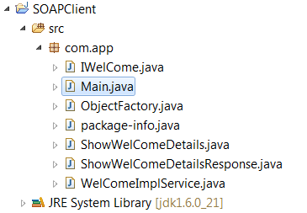

Write main Program:

**package** com.app;

**import** java.net.URL;

**import** javax.xml.namespace.QName;

**import** javax.xml.ws.Service;

**public** **class** Main {

**public** **static** **void** main(String[] args) **throws** Exception {

//TCP/IP Tracing method

URL url = **new** URL("http://localhost:8098/WS/hello?wsdl");

QName qname=**new** QName("http://app.com/", "WelComeImplService");

Service service=Service.*create*(url, qname);

IWelCome welcome=service.getPort(IWelCome.**class**);

String msg=welcome.showWelComeDetails("1000", 22210);

System.*out*.println("done"+msg);

/*Standard Clinet code*/

WelComeImplService serviceObj=**new** WelComeImplService();

IWelCome welcomeObj=serviceObj.getWelComeImplPort();

String msg2=welcomeObj.showWelComeDetails("1000", 22210);

System.*out*.println("done"+msg2);

}

}

Checking wsdl file

: <http://localhost:9000/WS/hello?wsdl>

Working with TCP /IP monitor:

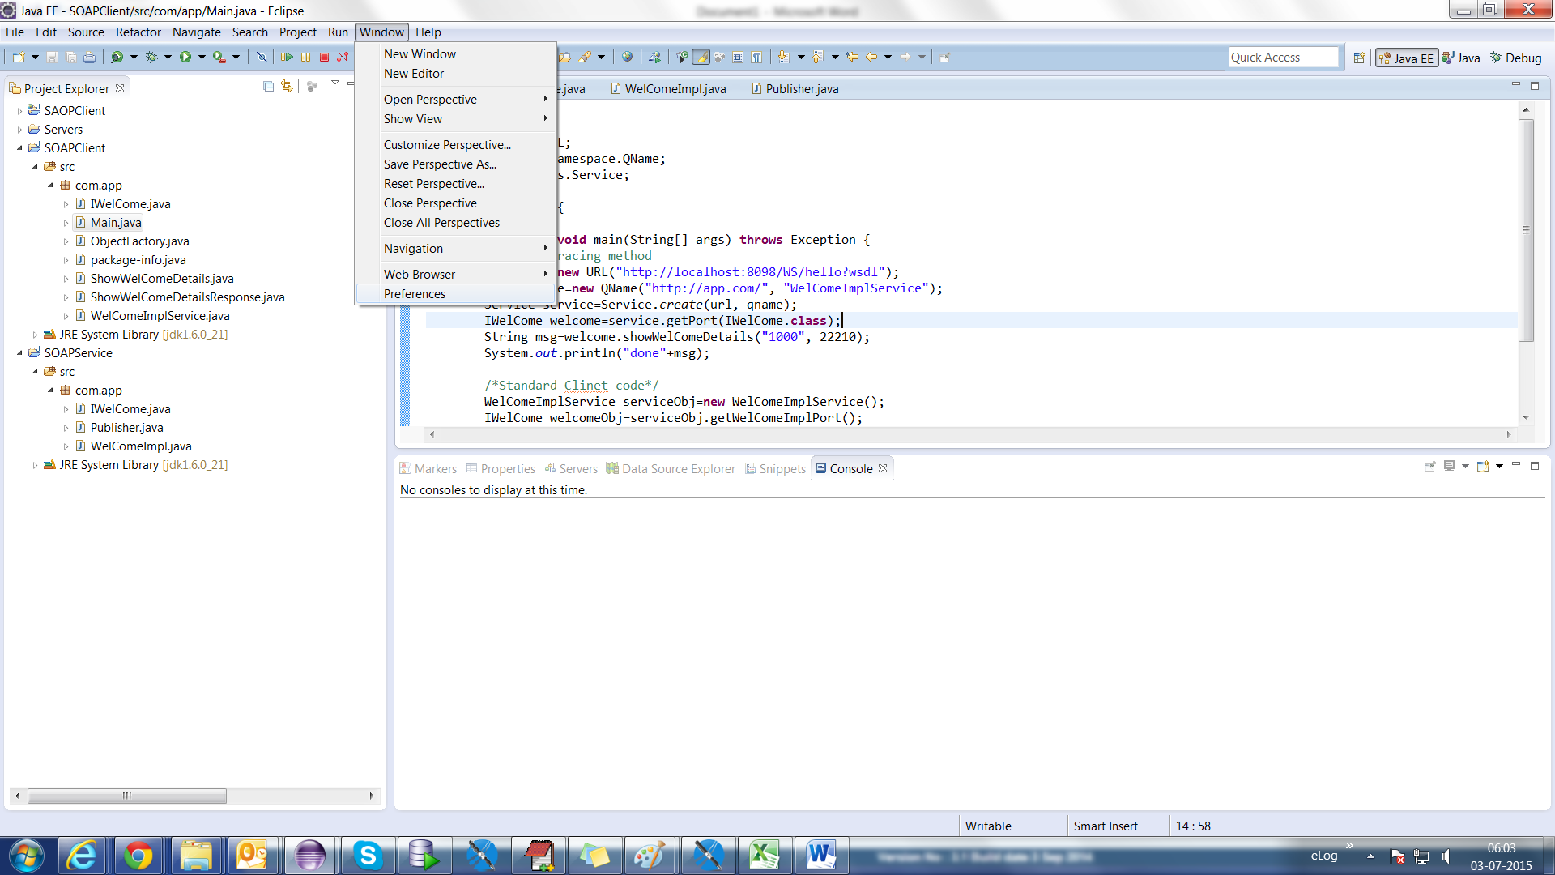

Select preference here

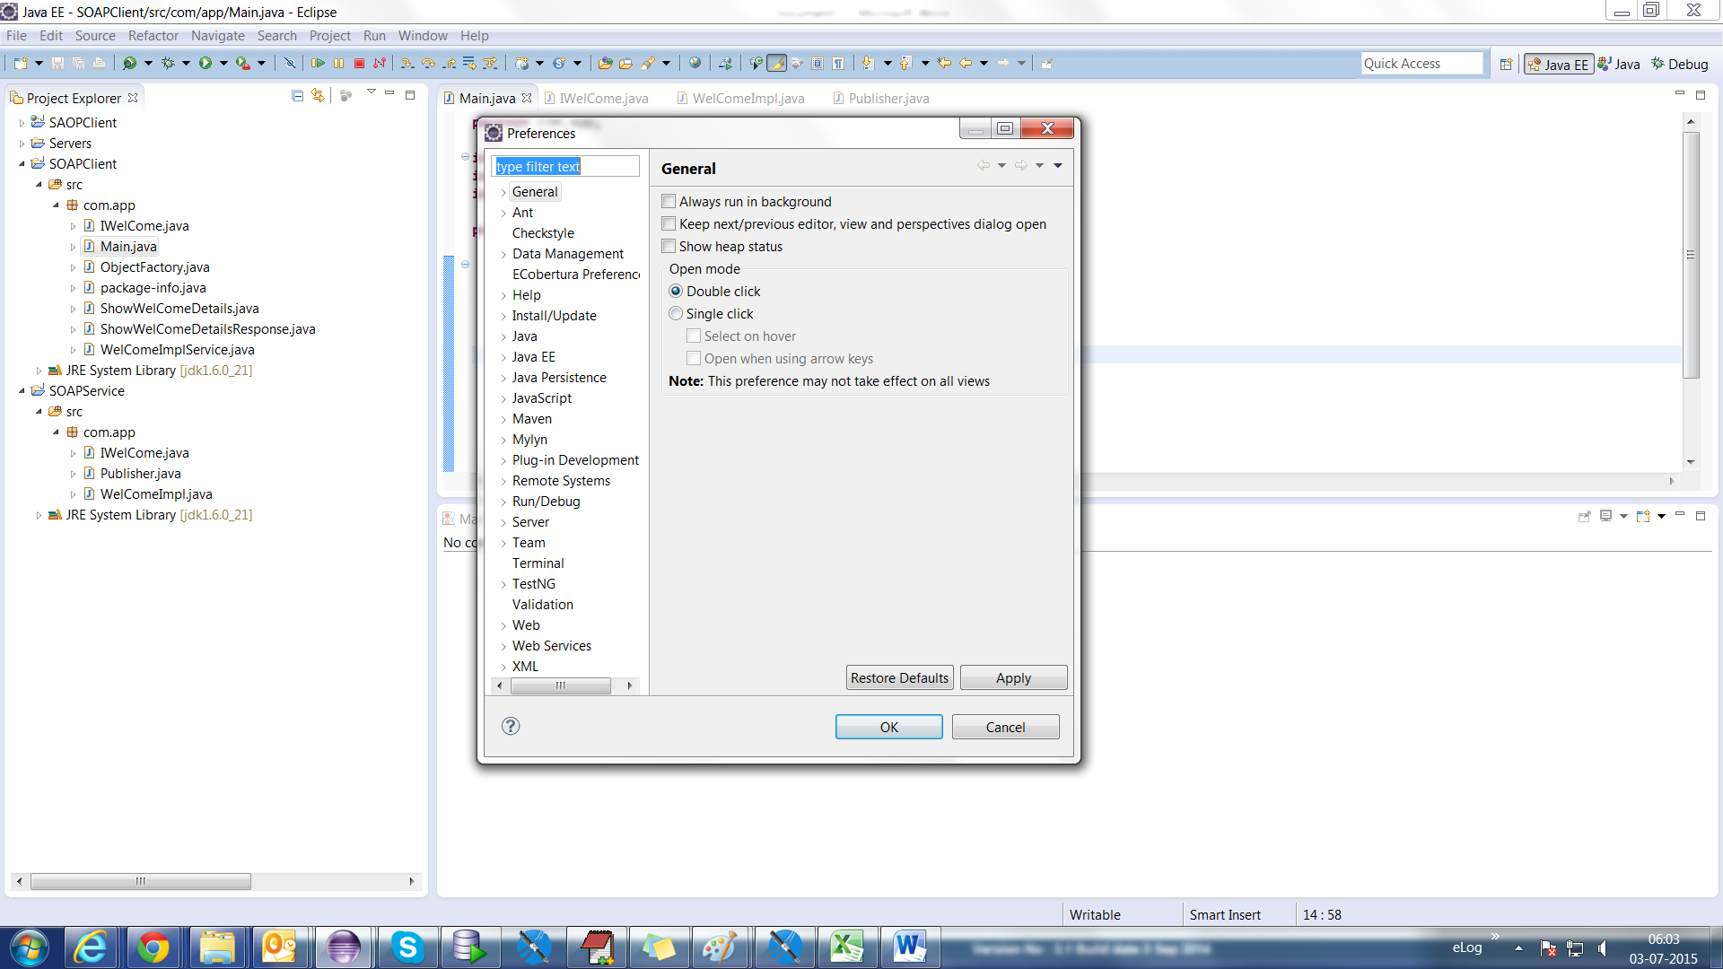

Type tcp/ip and select tcp/ip monitor

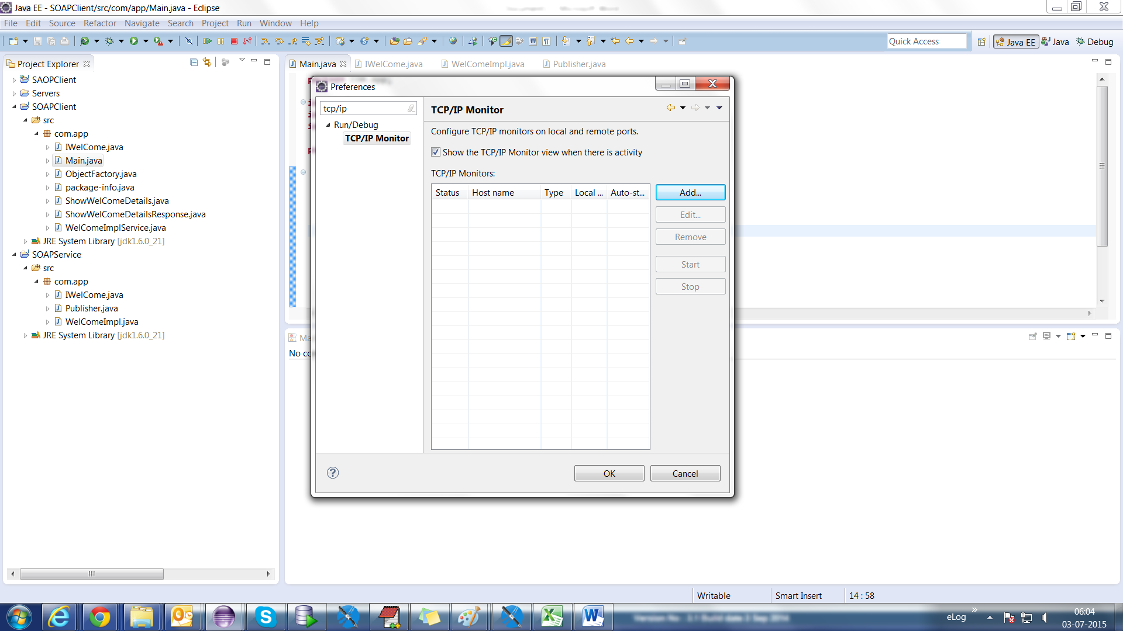

Click on add button and fill details:

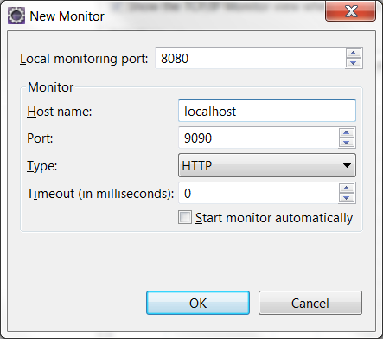

Port: it should be wsdl port number.

Ex: <http://localhost:9000/WS/hello?wsdl>

Then port number is: 9000

Local Monitor number is: Client Program URL Port number.

Ex: URL url = **new** URL("http://localhost:8098/WS/hello?wsdl");

Local port number: 8098

Click ok button

Click on start button

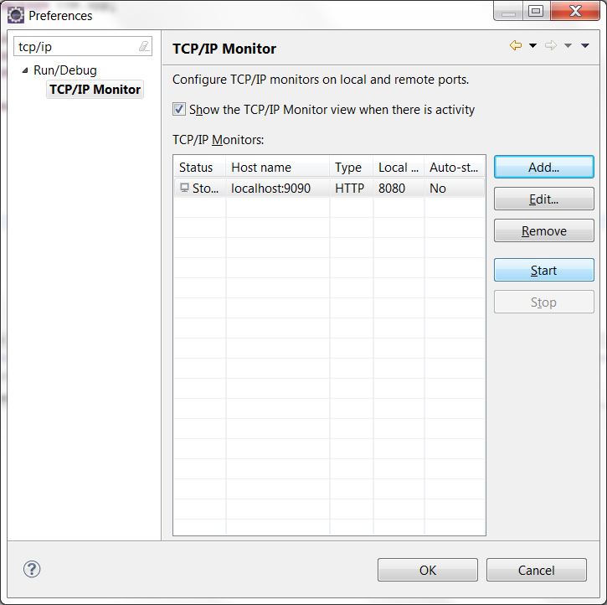

Click on ok button.

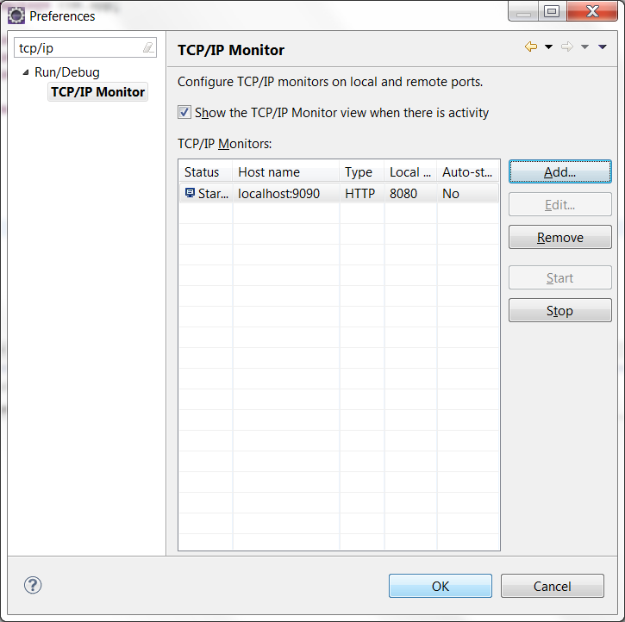

Enable a TCP/IP window.

Windows-> show view-> Other-> type TCP/IP

